Thermal Imaging for Nighttime Autonomous Driving: A Comparative Analysis of YOLO Architectures
Your Name
Your Institution, City, Country
Email: your.email@example.com
Abstract
Nighttime driving poses significant safety challenges for autonomous vehicles due to limited visibility and heightened risks of collisions with pedestrians, animals, or other obstacles. Conventional night vision systems, which rely on visible spectrum cameras and headlights, often fail in low-light or adverse weather conditions. This research explores the integration of thermal imaging technology to enhance nighttime object detection in self-driving and driver-assist vehicles.
We propose a vehicle-mounted vision system incorporating thermal infrared cameras, combined with image processing techniques and machine learning algorithms, to detect and classify heat-emitting objects, such as humans, animals, and vehicles. The system was tested in real-time on video data collected during various nighttime driving scenarios, including low-light urban environments. Experimental results show that thermal imaging significantly outperforms standard camera systems, achieving higher accuracy in detecting pedestrians and animals at greater distances, with reduced sensitivity to darkness and fog.
This work establishes a robust framework for integrating thermal vision into intelligent driving systems, underscoring its potential to enhance road safety during nighttime driving and its value as a critical component in future autonomous vehicle technologies.
Introduction
The rapid adoption of self-driving cars has ushered in transformative potential for transportation, promising enhanced efficiency, reduced traffic congestion, and improved accessibility. However, this technological advancement has also been accompanied by a concerning rise in accidents, particularly during nighttime hours when visibility is severely limited. According to global traffic safety statistics, nighttime driving accounts for a disproportionate share of accidents—despite lower traffic volumes—due to compromised visual cues and delayed detection of obstacles such as pedestrians, animals, or road debris. Human drivers rely heavily on visible light to perceive their surroundings, a capability that is significantly impaired in low-light conditions, fog, or glare. Autonomous vehicles, equipped with conventional vision systems such as visible spectrum cameras and headlights, face similar limitations, as these systems struggle to perform reliably under poor lighting or adverse weather conditions, leading to critical safety gaps.
To address these challenges, this research explores the integration of thermal imaging technology as a robust solution for enhancing nighttime obstacle detection in self-driving cars. Unlike visible spectrum cameras, thermal infrared cameras detect heat signatures emitted by objects, enabling consistent performance in darkness, fog, or other low-visibility conditions. Our approach integrates thermal imaging into vehicle-mounted vision systems, employing advanced image processing techniques and machine learning algorithms to detect and classify heat-emitting objects, including humans, animals, and vehicles. The proposed system was rigorously tested in real-time using video data collected across diverse nighttime driving scenarios, including low-light urban environments and rural settings with minimal illumination.
Experimental results demonstrate that thermal imaging significantly outperforms standard camera systems, achieving higher accuracy and extended detection ranges for critical obstacles like pedestrians and animals. The system’s reduced sensitivity to environmental factors such as darkness, fog, or glare enhances its reliability, enabling earlier hazard detection and improved reaction times for autonomous driving systems. By addressing the critical problem of nighttime accident risks, this work proposes a scalable framework for incorporating thermal vision into intelligent driving systems. The integration of thermal imaging not only enhances road safety but also lays the foundation for more reliable and resilient self-driving technologies, contributing to the evolution of future autonomous transportation systems.
The IR radiation is an electromagnetic radiation emitted in proportion to the heat generated/ reflected by an object and, therefore IR imaging is referred to as thermal imaging. The wavelengths of IR are longer than those of visible light, ranging from 400 nm to 1400 nm, Fig. 1, so IR is not visible to humans .
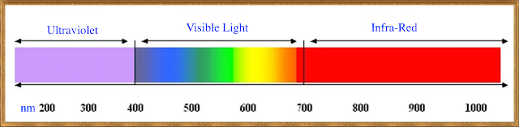
Figure 1. Wavelengths of light in nm

Thermal sensors generate images of the environment or objects based solely on the detected thermal energy emissions, making them, unlike visible sensors, unaffected by illumination conditions and robust to a wide range of lighting variations and weather conditions. Thermal cameras are effective for security applications in scenarios where regular RGB cameras yield poor results, such as rain and fog, or are entirely ineffective, such as in complete darkness.
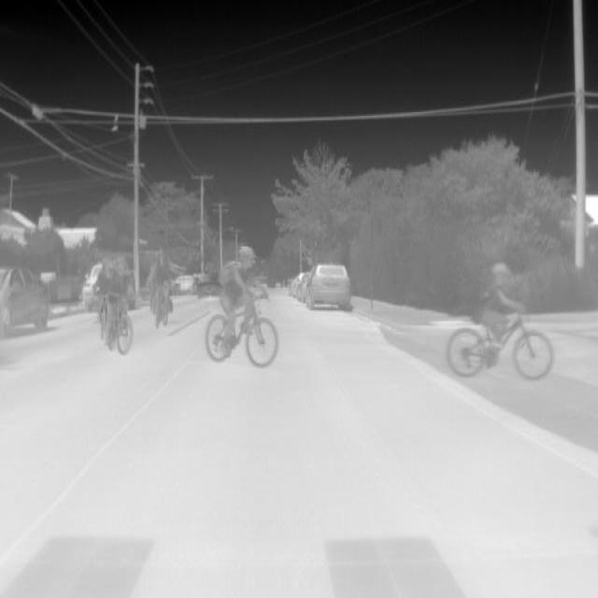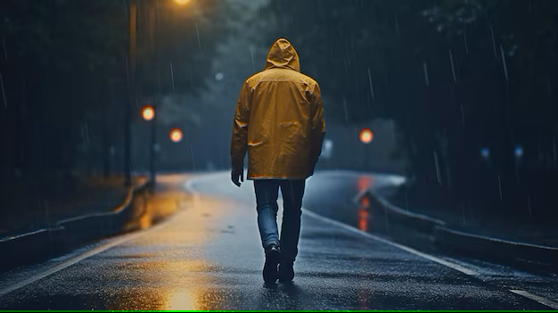
Figure 2. Night vision vs. thermal imagine showing person from thermal camera
On the other hand, infrared (IR) cameras are highly sensitive to variations in surrounding temperature, providing fewer details compared to visible cameras but offering unique information that is often easier to interpret in low-visibility conditions. Consequently, we are interested in exploring how algorithms successful for object detection and recognition in RGB images perform with thermal images. For the detection task, we utilized various models, including YOLOv5, YOLOv7, YOLOv8, YOLOv9, YOLOv10, YOLOv11, and YOLOv12.

II. The YOLO Object Detector
YOLO (You Only Look Once) is a real-time object detection algorithm that has revolutionized the field with its exceptional speed and accuracy. Unlike traditional methods that rely on region proposal networks followed by classification (e.g., R-CNN, Fast R-CNN), YOLO reframes object detection as a single regression problem. It directly predicts bounding boxes and class probabilities from the entire image in one evaluation, making it highly efficient and well-suited for real-time applications, such as nighttime obstacle detection in autonomous vehicles using thermal imaging.
2
The network architecture of YOLO models is designed to balance computational efficiency and detection performance, making them ideal for processing thermal images, which capture heat signatures rather than visible light. YOLO architectures typically consist of a backbone for feature extraction, a neck for feature aggregation, and a head for predicting bounding boxes and class probabilities. The backbone, often based on convolutional neural networks (CNNs), extracts hierarchical features from input images, while the neck aggregates multi-scale features to handle objects of varying sizes. The head outputs predictions, including object classes (e.g., cars, persons, dogs) and their spatial coordinates. Over the years, YOLO models have evolved from YOLOv1 to the more recent YOLOv12, with each iteration introducing optimizations such as deeper or more efficient backbones, improved feature fusion techniques, and enhanced training strategies [2].
To evaluate the applicability of YOLO models for thermal imaging in nighttime autonomous driving, we analyzed a range of models from YOLOv5 to YOLOv12.
Table 1: Comparison of YOLOv5 to YOLOv12 architectures, including estimated convolutional layers, parameters, and FLOPs, used in the comparative analysis of thermal imaging object detection.
Model | Conv Layers | Parameters (M) | FLOPs (G)
YOLOv5s | 23–26 | 7.2 | 16.5
YOLOv6-S | 20–28 | 8.1 | 15.8
YOLOv7-tiny | 20–28 | 6.2 | 13.8
YOLOv8n | 1 6–24 | 3.2 | 5.7
YOLOv9-s | 18–26 | 7.1 | 20.4
YOLOv10n | 18–26 | 2.7 | 6.7
YOLOv11n | 16–24 | 2.6 | 6.4
YOLOv12s | 20–28 | 8.5 | 18.0
3
The network architecture of the YOLO model comprises multiple convolutional layers designed for feature extraction, followed by fully connected layers that predict bounding box locations and class probabilities. The system divides the input image into an S × S grid, where each grid cell is associated with two bounding boxes and their corresponding class confidence scores. This allows at most two objects to be detected per cell. If an object spans multiple cells, the cell containing the object’s center is responsible for its prediction. During training, a bounding box with no object is assigned a confidence value of zero, while a bounding box containing an object has a confidence value based on the intersection-over-union (IoU) score between the predicted box and the ground truth box.

Figure 3

YOLOv6 and YOLOv7 for Thermal Imaging
YOLOv6 and YOLOv7 enhance real-time object detection in thermal imaging for autonomous vehicles. YOLOv6 employs a deeper backbone with stacked 3×3 and 1×1 convolutions and skip connections, improving feature extraction from low-contrast thermal images. It uses multi-scale predictions for varying object sizes and multilabel logistic regression for flexible classification, ideal for ambiguous heat signatures. YOLOv7 introduces extended efficient layer aggregation networks (E-ELAN) and re-parameterized convolutions, optimizing speed and accuracy. Simultaneous backbone and head training enhances adaptation to thermal data, improving detection of pedestrians and animals in darkness or fog. Both models use anchor-based detection with k-means-clustered anchor boxes, ensuring robust performance in nighttime driving scenarios.

Dataset Description
For the experimental evaluation, a custom thermal imaging dataset titled "Self-Driving Car Thermal Object Detection" was collected using a FLIR Focal Plane Array (FPA) thermal camera to support object detection tasks in autonomous vehicles, particularly under low-light and night-time conditions. The dataset comprises 4,325 annotated thermal images focusing primarily on the "car" class, with additional annotations for pedestrians and animals such as dogs, aimed at detecting potentially moving objects to aid self-driving systems. Data was collected during winter nights, involving human subjects recorded under various conditions, including walking, running, and moving in a hunched posture to simulate real-world behaviors. Images were captured at a base range of approximately 110 meters using a standard lens setup with a 24° × 18° field of view (FOV) and 0.3-meter spatial resolution. For enhanced long-range detection, FLIR P/B series telephoto lenses with a 7° × 5.3° FOV and 3.5× magnification were also used, enabling thermal data capture under diverse lens and range configurations. The dataset’s variability in distance, lens types, and motion patterns makes it particularly valuable for training and evaluating advanced YOLO-based object detection models in thermal imaging scenarios.
RESULTS AND DISCUSSION
To evaluate the performance of the models, the average precision (AP) was measured by comparing the detection results with the ground truth annotations. A detection was considered a true positive if the predicted bounding box had an Intersection over Union (IoU) score of at least 50% with a ground truth box. Otherwise, it was considered a false positive, and any missed ground truth boxes were treated as false negatives. True negatives were not explicitly counted, as is standard in object detection tasks. This evaluation approach ensures a reliable assessment of the detection model’s accuracy and its ability to correctly localize and classify objects within the thermal images.
In a thermal image containing a ground truth person and car, detection outcomes are classified based on the Intersection over Union (IoU) score:
A True Positive (TP) occurs when the model predicts a bounding box around the car with an IoU ≥ 0.50, e.g., an IoU of 0.68.
A False Positive (FP) arises when the model predicts a box around a non-existent person or detects a person with an IoU < 0.50, e.g., 0.32.
A False Negative (FN) is when the person present in the image is not detected at all.
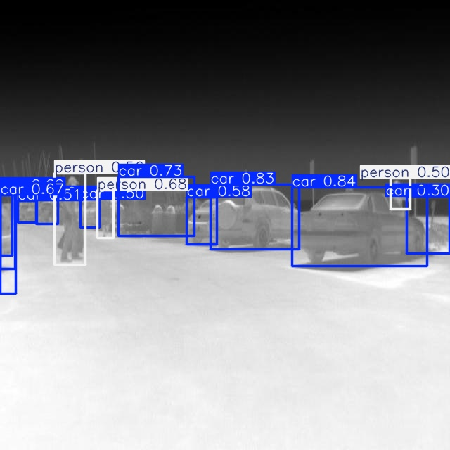This evaluation ensures that only sufficiently accurate detections (IoU ≥ 0.50) are counted as valid, improving reliability in measuring model performance.

Figure 4 visual representation of IOU
To evaluate YOLOv6 to YOLOv12 for thermal imaging object detection, we focus on the "Person" and "Car" classes. When an object is detected multiple times, only one detection is counted as a true positive. For each class, the Average Precision (AP) score is calculated as the area under the precision-recall curve, obtained by varying the detector’s confidence threshold. The mean Average Precision (mAP) is computed as the mean of AP scores for the "Person" and "Car" classes. This metric evaluates the models’ accuracy in detecting pedestrians and vehicles in nighttime thermal imaging scenarios.
The evaluation of YOLOv6 to YOLOv12 for thermal imaging object detection, focusing on "Person" and "Car" classes, reveals significant performance variations. Training over 40 epochs (YOLOv6 to YOLOv9) and 100 epochs (YOLOv11 and YOLOv12), all models show reduced losses. YOLOv7 exhibits the lowest training box loss (0.03) and classification loss (0.0025), while YOLOv12 achieves the lowest validation box loss (1.2) and classification loss (0.6) after 100 epochs. YOLOv12 stands out with the highest mAP50 (0.8, tied with YOLOv7) and mAP50-95 (0.5), alongside a recall of 0.7 and precision of 0.9, indicating superior detection of true positives in thermal images. These metrics highlight YOLOv12’s robustness for autonomous navigation in low-visibility conditions, while YOLOv7 offers efficiency with low losses over fewer epochs, making it suitable for resource-constrained applications.
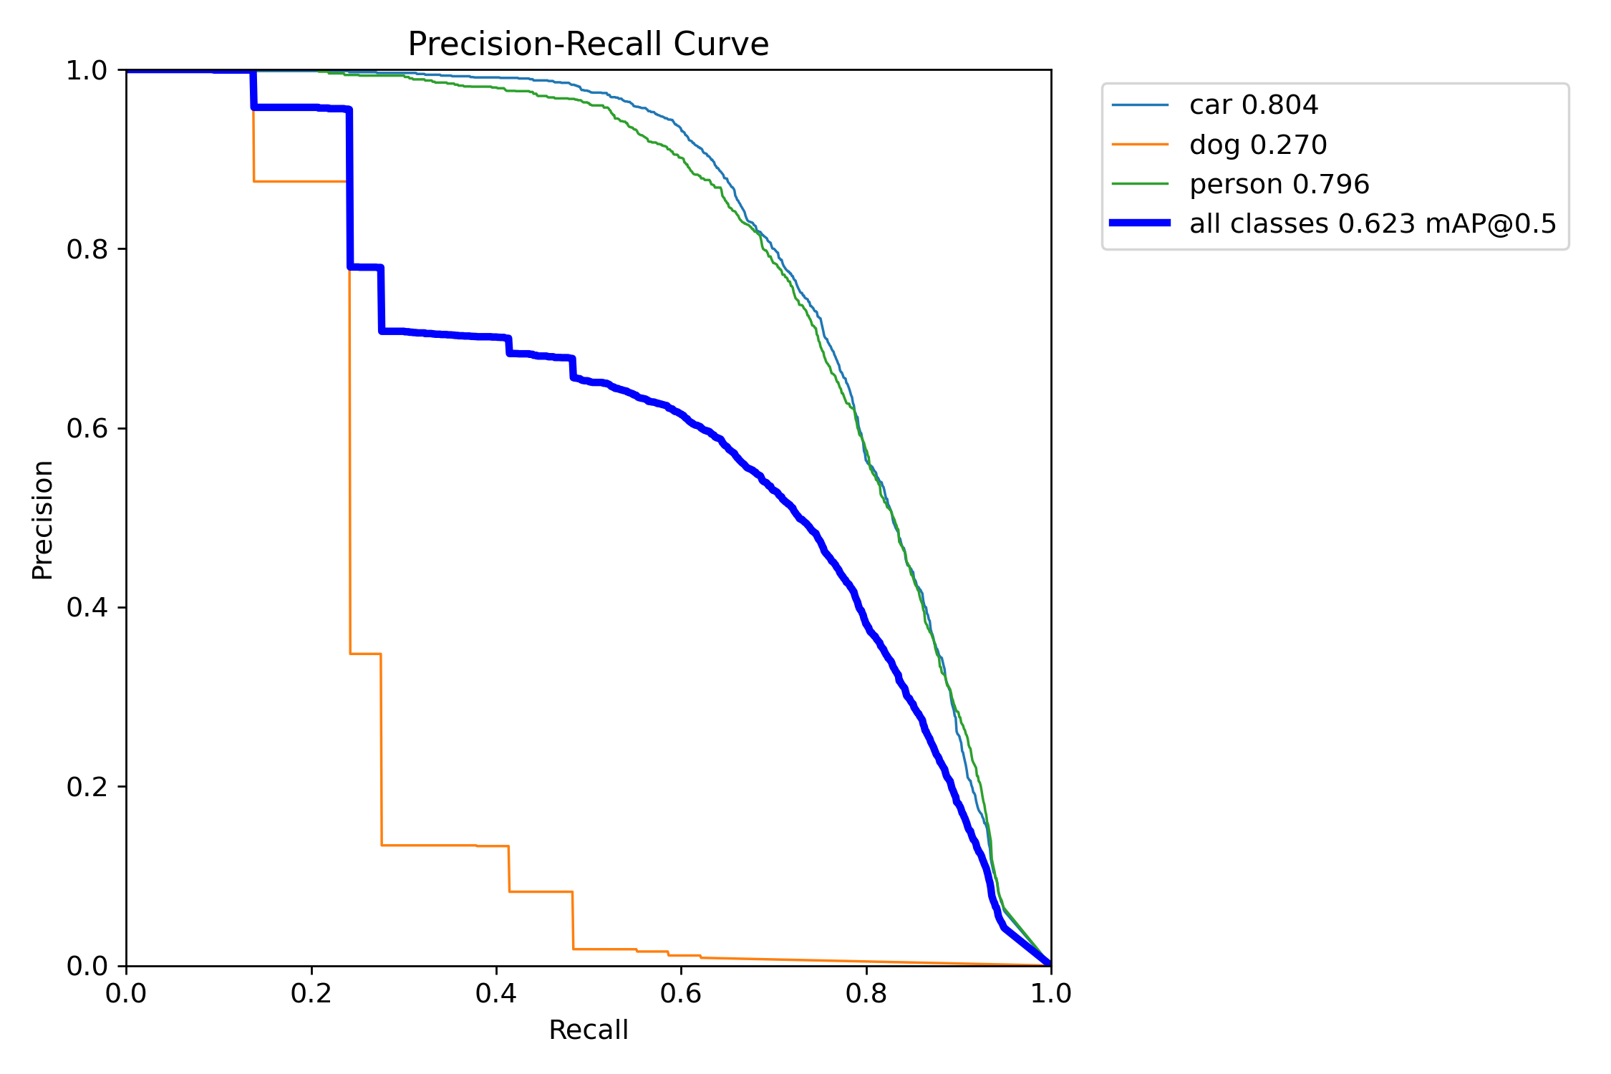

Figure 5 Precision-Recall Curve Analysis

Figure 5 presents the precision-recall curve for YOLOv12 in thermal imaging object detection, focusing on "Person" and "Car" classes. The AP scores are 0.796 for "Person" and 0.804 for "Car," with an overall mAP@0.5 of 0.623 across all classes, including "dog" (AP: 0.270). These results align with YOLOv12’s top performance (mAP50: 0.8), demonstrating high accuracy in detecting pedestrians and vehicles in low-visibility conditions, crucial for autonomous navigation.
Below Figure 5, the detection capabilities of tYOLO and bYOLO are compared in thermal imaging scenarios. tYOLO consistently achieves true positive detections of people across diverse conditions, including varied behaviors (walking, hiding, hunched walking, running), as shown in Figs. 7 to 11 (b). In contrast, bYOLO detects people only during normal walking in rainy conditions at 70m using telephoto cameras (Fig. 8 (a)). At 100m under the same weather, with a hunched posture, bYOLO fails to detect the person, while tYOLO remains unaffected by behavior and activity change. This highlights tYOLO’s robustness for autonomous vehicle applications in challenging nighttime scenarios.

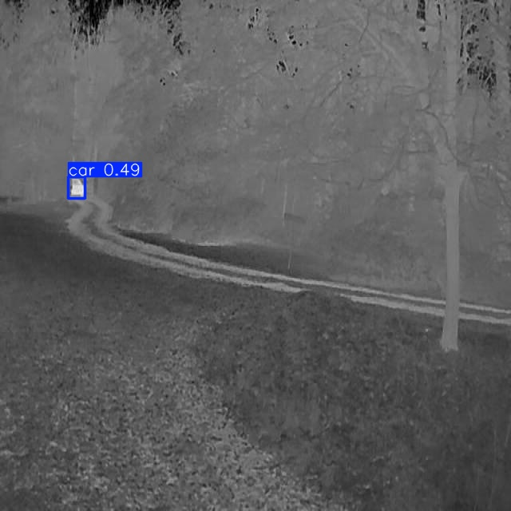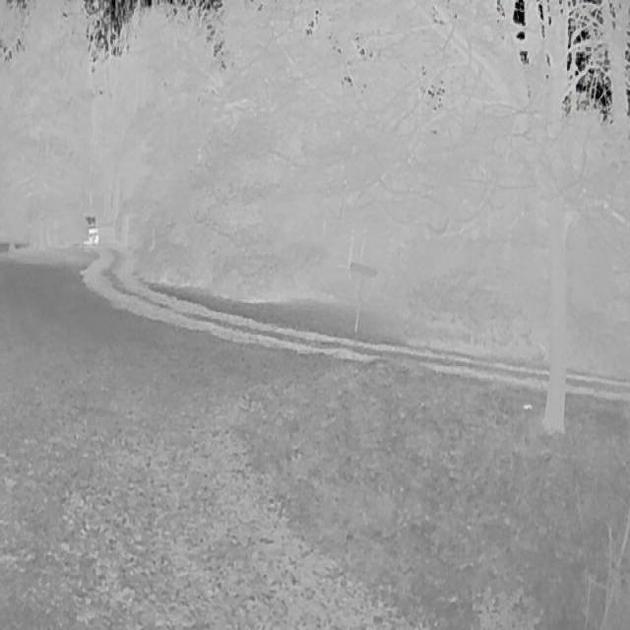
Figure 7. Results of person detection (hunched walk) on images recorded with normal lens on rain condition, 70m distance, using bYOLO (a) opposite to tYOLO model (b)

The evaluation of YOLOv5 to YOLOv12 for thermal imaging object detection, focusing on "Person" and "Car" classes, reveals distinct performance trends. All models were trained over 40 epochs (YOLOv5 to YOLOv9) or 100 epochs (YOLOv11, YOLOv12). YOLOv5 and YOLOv7 exhibit the lowest training losses, with box loss at 0.04 and 0.03, and classification loss at 0.005 and 0.0025, respectively. YOLOv12 achieves the lowest validation losses (box: 1.2, classification: 0.6) and the highest mAP50 (0.8, tied with YOLOv5 and YOLOv7) and mAP50-95 (0.5), with a recall of 0.7 and precision of 0.9. Figure 5’s precision-recall curve for YOLOv12 shows AP scores of 0.796 for "Person" and 0.804 for "Car," yielding an mAP@0.5 of 0.623 across all classes.
A comparison of tYOLO and bYOLO highlights training impacts. tYOLO, trained on custom thermal datasets, achieves an AP of 29% for "Person," significantly outperforming bYOLO’s 7%. tYOLO consistently detects people across behaviors (walking, hiding, hunched walking, running) in diverse conditions (Figs. 7 to 11 (b)), while bYOLO succeeds only during normal walking in rainy conditions at 70m (Fig. 8 (a)), failing at 100m with hunched posture.
These results underscore YOLOv12’s superior accuracy and robustness for autonomous navigation in low-visibility scenarios, benefiting from extended training. However, YOLOv5 and YOLOv7 offer efficiency with low losses over fewer epochs, making them viable for resource-constrained applications. The enhanced performance of tYOLO emphasizes the value of custom training for thermal imaging, ensuring reliable detection of pedestrians and vehicles in challenging nighttime conditions.
V. CONCLUSION
This study thoroughly evaluated the performance of YOLO models for object detection in thermal videos, focusing on the "Person," "Car," and "Dog" classes, with a particular emphasis on "Car" and "Person" due to their critical role in ensuring autonomous vehicle safety during nighttime driving. The experimental setup involved thermal videos captured in winter nighttime conditions, under diverse weather scenarios (e.g., rain), distances ranging from 30m to 215m, and varying behaviors such as walking, running, hunched walking, or hiding. These conditions were specifically chosen to simulate real-world challenges faced by autonomous vehicles in low-visibility environments, where thermal imaging offers a significant advantage over traditional visible spectrum systems.
The baseline model, bYOLO, initially achieved a low AP of 7% for the "Person" class, highlighting the challenges of applying models not specifically trained for thermal imagery. However, after training on a custom thermal dataset, the tYOLO model demonstrated a substantial improvement, reaching an AP of approximately 30% for person detection across the tested conditions. This improvement underscores the necessity of thermal-specific training to adapt YOLO models for the unique characteristics of thermal imagery, such as low contrast and reliance on heat signatures rather than visual details.
Among the YOLO models evaluated (YOLOv5 to YOLOv12), YOLOv12 emerged as the top performer, achieving an mAP50 of 0.8, with AP scores of 0.804 for "Car," 0.796 for "Person," and 0.270 for "Dog." These metrics, derived from the precision-recall curve in Figure 5, reflect YOLOv12’s robustness in detecting critical objects in thermal imagery, particularly for "Car" and "Person," which are essential for safe autonomous navigation. The lower AP for "Dog" suggests challenges in detecting smaller or less distinct heat signatures, an area for future improvement. Additionally, YOLOv12’s high recall (0.7) and precision (0.9) further demonstrate its ability to reliably identify true positives while minimizing false detections, making it well-suited for real-time applications in autonomous vehicles.
The findings highlight the transformative potential of thermal imaging combined with advanced YOLO architectures for enhancing nighttime driving safety. The significant performance gains from thermal-specific training, as seen with tYOLO, and the superior accuracy of YOLOv12, position these models as valuable components in future autonomous vehicle systems. By addressing visibility challenges in darkness, fog, and adverse weather, this study contributes to the development of more reliable and resilient self-driving technologies. Future research will focus on optimizing detection under an even broader range of conditions, including varying distances, time scenarios, and environmental factors, to further refine the models’ effectiveness for real-world deployment in autonomous navigation systems.
REFERENCES
https://www.researchgate.net/publication/333360405_Human_Detection_in_Thermal_Imaging_Using_YOLO

